

**Arab Academy for Science, Technology and Maritime Transport**

**College of Computing and Information Technology**



Presented by:- Ahmed Abd El Gawad

Ahmed Hesham

Ahmed Mohamed Ahmed

Safinaz Hamdy

Youssef Yasser

Car Agency Analysis

Presented To: Eng.Rana

**Table of Contents**

**Introduction** 2

**Objectives** 2

**Explanation of Each Step of the Project** 4

**Columns** 4

**Measures** 4

**Reports** 5

**Transformations** 6

**Screenshots** 7

**Conclusion** 9

# **Introduction**

A car is one of a person's most expensive purchases and the showroom today plays an important role in helping clients make that decision. An outlet in an increasingly segmented market needs to cater for a variety of consumers and their needs. In today’s brand-driven society, cars and lifestyle overlap and the rental environment should reflect the customer’s preferences The Car Rental System is the facility to rent cars easily. Some people cannot effort of having a car, for those people this system becomes very helpful. This system includes various cars, as per the customer order and comfort, it place the order and deliver the car as per the location within the area. So, we used PowerBi to ease the display of data and information, and to make it more organized and filtered for the best use

# **Objectives**

A car rental agent's role is primarily with completing and fulfilling customer orders. They can also participate in other roles, including completing requests for maintenance, offering general customer service, and providing information on services that are provided. As in other customer-oriented jobs, car rental agents connect with the public regularly and can be expected to perform specific sales tasks as part of the work. To demonstrate your talent as a communicator, your resume purpose should be clearly defined, because written statements and documenting details are instrumental to this type of work.

Hiring managers are encouraged to highlight your relevant skills and work experience, but also be sure to express your interest in working for their specific business. Citing the company by name is an excellent way to prevent the presence of a boilerplate resume as part of your factual speech.

**1.** Friendly individual seeks car rental agent position with our Company to employ good knowledge of automobiles and the local region to assist traveling customers.

**2.** Experienced retail worker seeks car rental agent position at our Company to utilize good people skills, attention to detail, and capable sales techniques.

**3.** Seeking to obtain car rental agent position with our Company that will benefit from helpful demeanor, good communication skills, and experience working with cars and light trucks.

**4.** Motivated individual seeks car rental agent position at our Company to go above and beyond in order to offer excellent service and customer satisfaction.

**5.** Experienced front desk clerk seeks car rental agent position at our Company which will benefit from two years of booking reservations and providing outstanding customer care in a high-end hotel.

# **Explanation of Each Step of the Project**

## **Columns**

**Cars Table**

Category = RELATED (categories [Cat_ID, Label])

**Categories Table**

Cat_ID, Label = [cat_id] & " , " & [cat_label]

**Customers Table**

Cust_ID,Full Name = [id] & " , "& [first_name] & " " &[last_name]

**Locations Table**

Loc_id,State = [loc_id] & " , "& [lstate]

**Phone Table**

Location State = RELATED(locations[Loc_id,State] )

**Reservations Table**

PickUp Location State = RELATED(locations[lstate])

Reserved Days = DATEDIFF([p_date],[r_date],DAY)

Return Location State = RELATED(locations[lstate])

## **Measures**

**Cars Table**

Total Cars = COUNTROWS(ALL(cars))

**Categories Table**

Total Categories = COUNTROWS(ALL(categories))

**Customers Table**

Total Customers = COUNTROWS(ALL(customers))

**Locations Table**

Total Locations = COUNTROWS(ALL(locations))

**Phone Table**

Count of Phones total for Location =

CALCULATE(COUNTA('phones'[phone_id]), ALLSELECTED('phones'[loc_id]))

**Reservations Table**

Count of Reserved Cars for Customers =

CALCULATE(

    COUNT('reservations'[VIN]),

    ALLSELECTED('reservations'[cust_id])

)

Total Profit = SUM(reservations[amount])

Total Reservations = COUNTROWS(ALL(reservations))

## **Reports**

1. **Show** the number of types of cars

**Show** the Number of each car rented by model.

1. **Show** the number of rented cars by each country to show what countries rent cars the most

**Show** the total profit of renting cars each year

1. **Show** the total reserved days for customers & total customers per year

**Show** reserved days & total profit by customer id

**Show** Total profit by car model

## **Transformations**

1. **In Table Customers:**

We merged columns first name & last name to Full_name

We merged columns country and state to Location.

1. **In Tables Location, Customers, & Reserved:**

We Replaced Values

1. **In Table Cars:**

We changed column name

## **Screenshots**

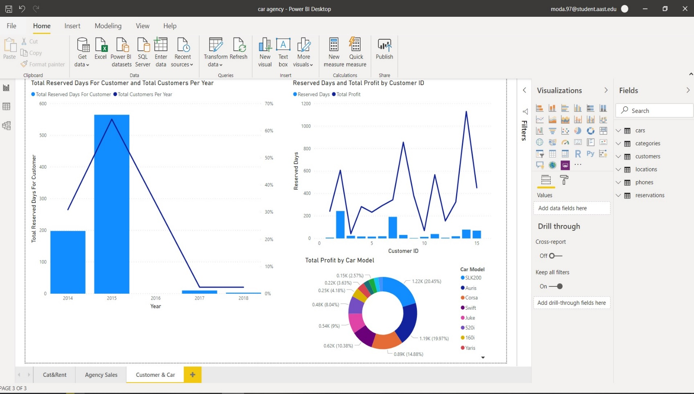

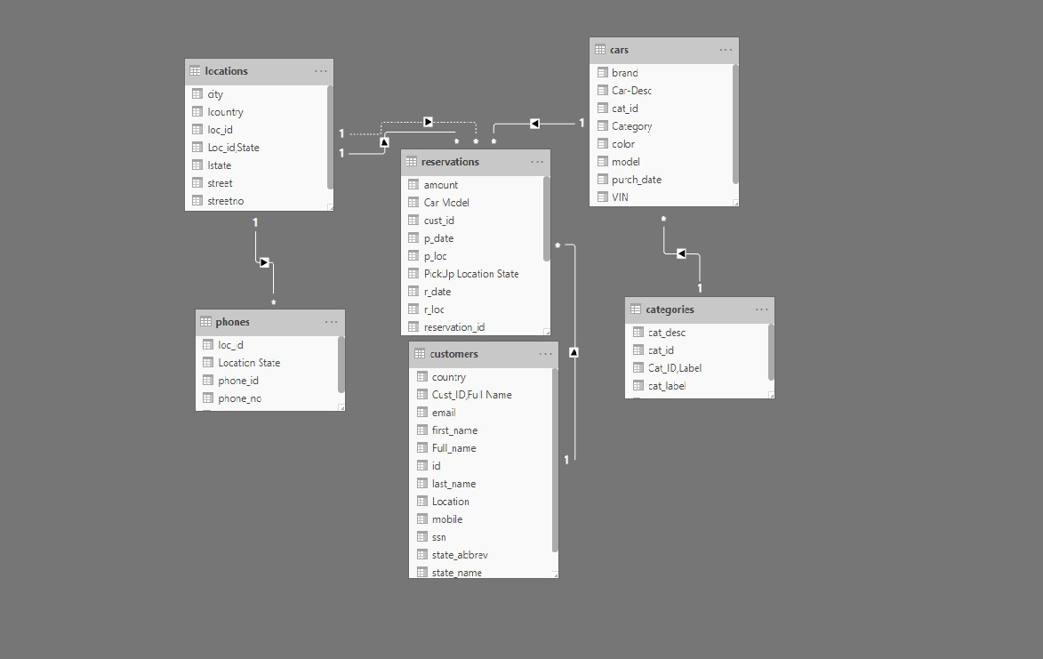

# **Conclusion**

The car rental operations have various problems. However, eliminating the proper configuration of the fleet implicitly reduces the problems of pulling cars and the logistics connected with the cars' supply & demand. The design of the fleet can be achieved by considering the fleet as a variable and the cars as a feature. the companies that use ride sharing are taking away a portion of business for short term car rentals. the portion is expected to increase over time. the adaptation of strategies such as gamification, increase customer service, real time GPS positioning and system automation are efforts made in improving operations and customer experience but cannot be adequate to win consumer confidence if the cost and satisfaction is not improved. PowerBi helped us a lot in designing and making this project, and made it easier for us to display various reports, visualizations and data to be well displayed.